Submitted by:

Aman Mishra 20BCE1662

Week 2

1. Here I create a table signup and add data into the table.

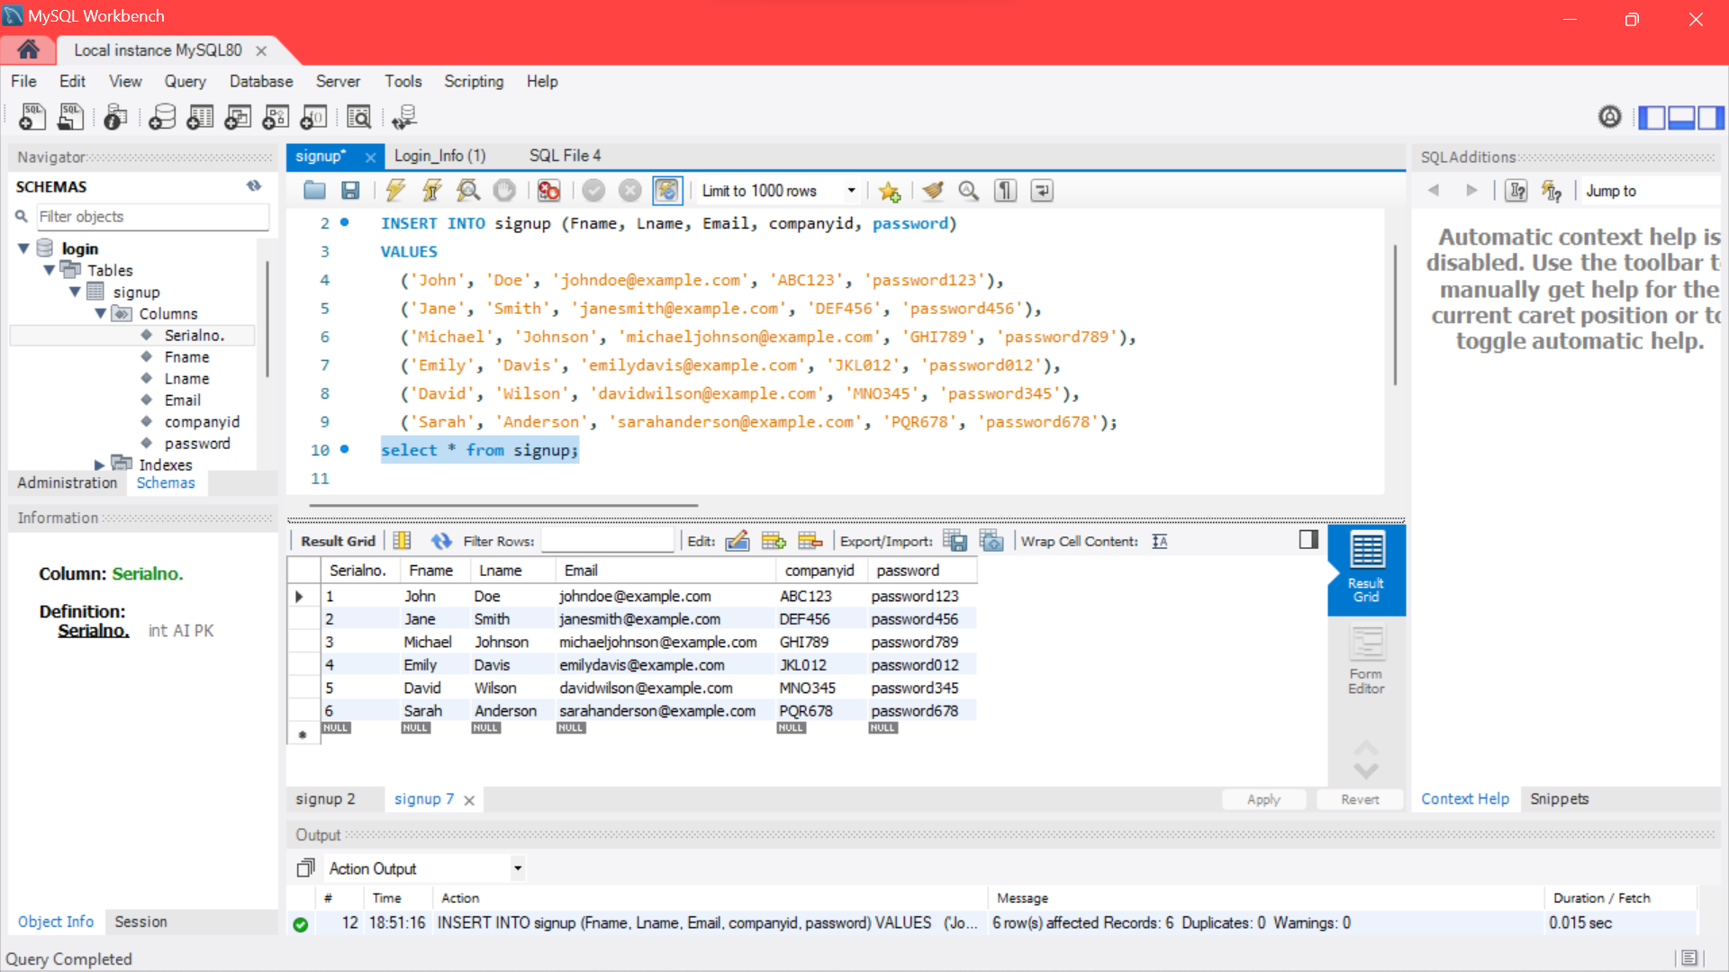

1. Now we use these commands for the table we created earlier

UPDATE COMMAND:

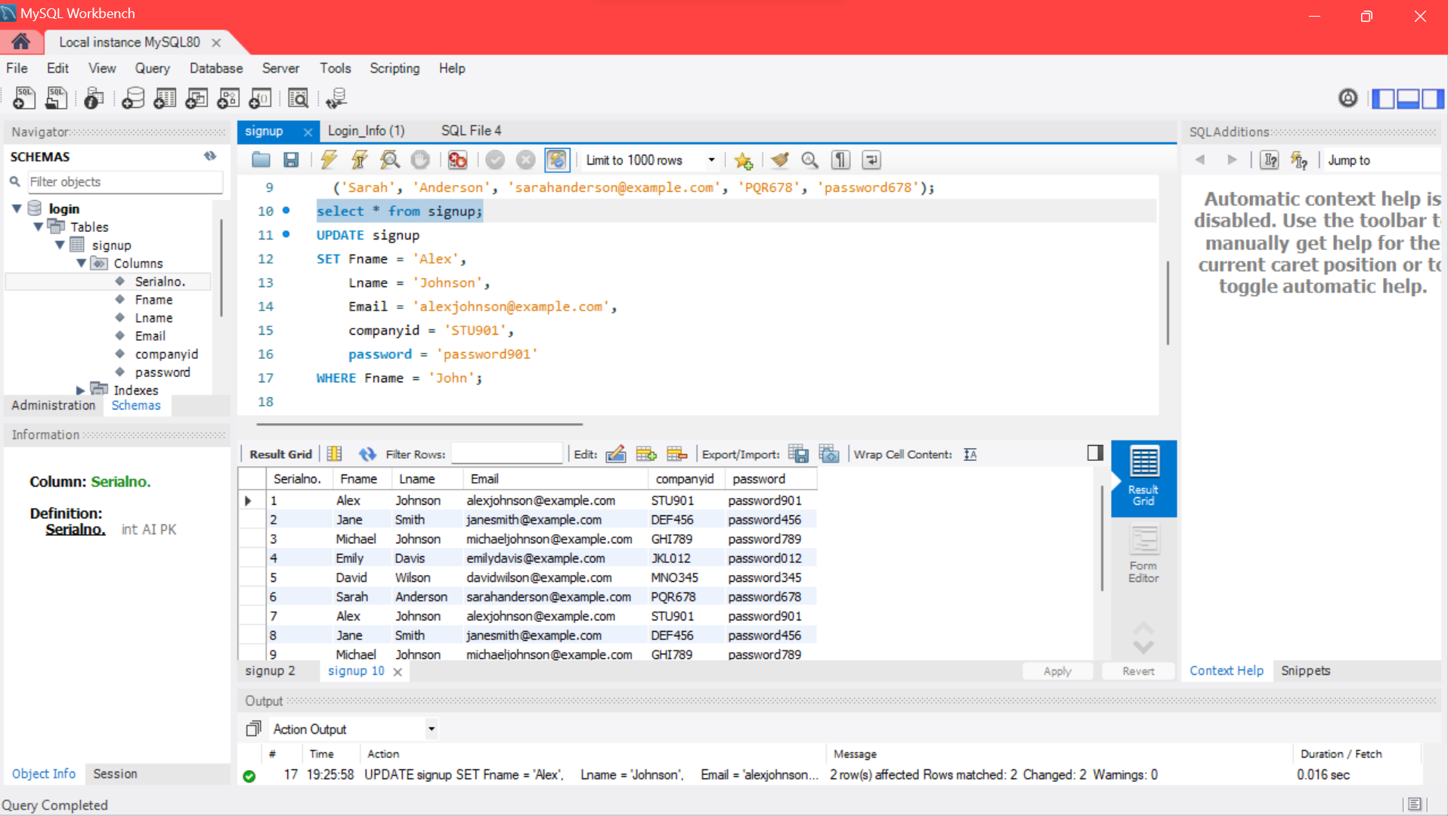

DELETE COMMAND:

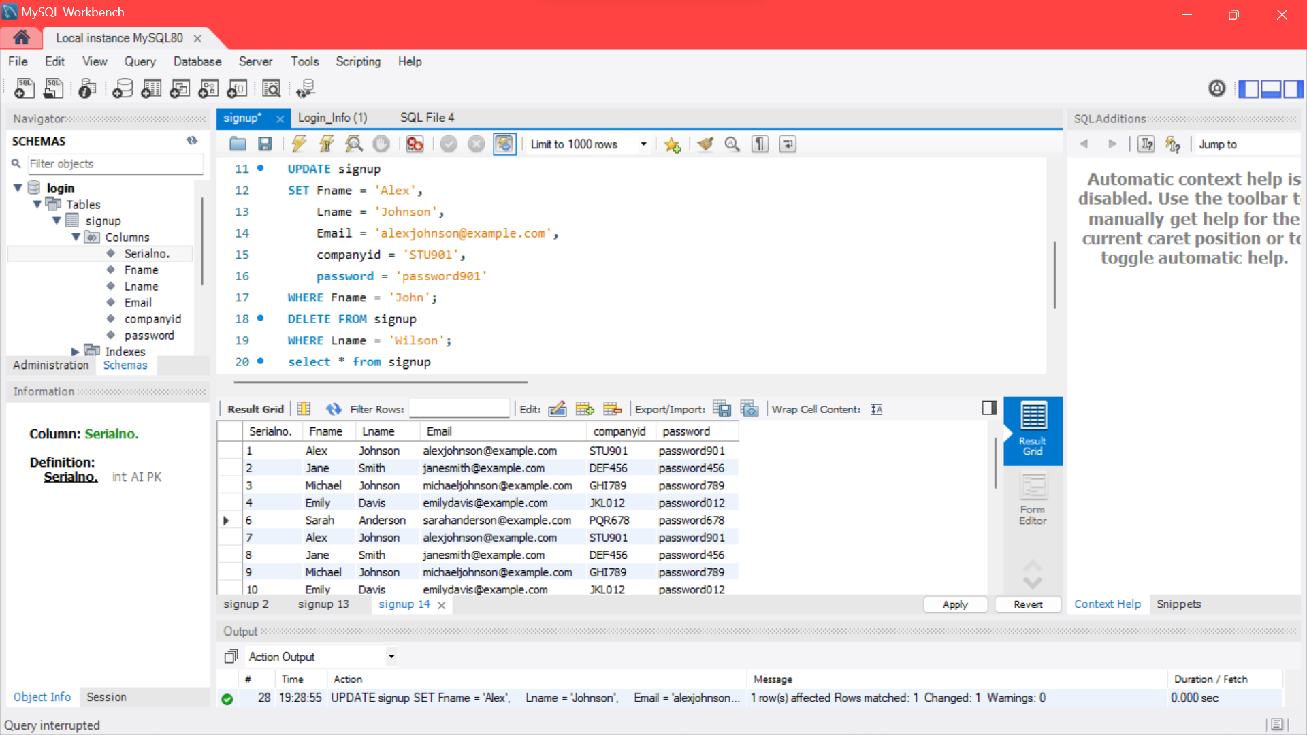

JOIN COMMAND:

